Waiting Lists in Northern Ireland – Introduction Part Two.

This project looks at examining trends and behaviours across the wide range of hospitals in Northern Ireland. Healthcare waiting lists, like all aspects of national public sector healthcare policy are a deeply sensitive issue, concerns about the life and death of loved ones is put at odds with issues around capacity issues such as the supply of finance, labour, medicine, equipment and facilities. The drive to better efficiency and resourcefulness has to take account of the sensitivity of key stakeholders such as medical and ancillary healthcare staff, patients and their loved ones, and those in administration, as well as the taxpayers who rely on the system.

The problem of Northern Ireland’s waiting lists is difficult, and there are no easy or obvious answers.

According to Professor Deirdre Heenan, when compared to the Merseyside and Wirral region 227.48km across the Irish Sea as the crow flies, Northern Ireland’s statistics on long term waiting lists are poor.

*"Merseyside and Wirral has a population of two million and has 10 people on its waiting lists for more than a year," she said. "The equivalent here - where there is a population of 1.8m - is 120,000.” (cite Newspaper)*

While it is true that Northern Ireland (14,130 km2) contains twice as much area as the Liverpool City Region (723.97 km2) (LCRA 2019) , higher deprivation and higher disability the scale of the problem is quite startling. The scale of the problem compared to England and Wales is given below:

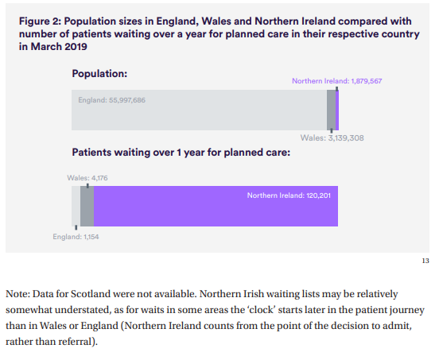

Northern Ireland’s healthcare issues has also been aggravated by the recent collapse in power sharing institutions, limiting decision making critical decision making capacity and is set to be further aggravated by the global COVID-19 corona virus pandemic increasing demand upon the local health service.

Hennan identifies historical failings in workforce planning for the health service in Northern Ireland, a shortage of important staff groups and a costly reliance on temporary workers.

In response to this challenge, Professor Heenan, co-wrote a report with Mark Dayan, a Nuffield Trust policy analyst, called the “Change or Collapse: Lessons from the drive to reform health and social care in Northern Ireland” <https://www.nuffieldtrust.org.uk/files/2019-07/nuffield-trust-change-or-collapse-web-final.pdf>

One of the main methods of addressing the crisis looks at community care and centralisation, highlighted in the opening section.

*“The health and social care system in Northern Ireland has seen seven fundamental reviews setting out major changes of direction in the last 20 years. Each has delivered a similar verdict: the country needs to reduce its reliance on hospitals, centralise some services for a critical mass at a smaller number of sites, and focus more on prevention and keeping people healthy.”*

The report looks at what is helping and hindering the system from delivering four broad goals indicated in the Bengoa review and set out in detail in “Delivering together” a Northern Ireland Executive paper that focuses on Health reform. It suggests

• Shifting care out of hospital, so that greater use is made of services that treat people in their neighbourhoods or their own home.

• Greater focus on prevention rather than curative services, and a focus on the health of the population as the essential task of health and social care.

• Increasing public trust in the system by **reducing waiting times** to an acceptable level

• The **centralisation of hospital services** where this improves quality or safety by concentrating key staff.

The report itself is largely qualitative seeking to understand different helpful or unhelpful factors. There were some quantitative analysis around finance, workforce and waiting times was also carried out. These focused on CCG-based funding model which addresses the factors which might determine whether Northern Ireland has higher or lower funding needs than other parts of the United Kingdom.

Project Definition and Methodology

What isn’t explored in this report, and what I believe is a good challenge for a data scientist, is the **relationship between waiting times and the positioning of hospitals**, independent of finance, the performance of the workforce, or the regional health care demand. Data on the waiting lists from Open NI, and vocational data for the hospitals involved can offer new insights into the scale of this issue.

It is my belief that clustering tools looking at waiting times in the context of regional performance can provide a useful metric in identifying where the scale of the problem exists in terms of either a trust.

Looking at the positioning of these clusters might also address where community care from outside a hospital, preventative measures to bad health may need to be introduced, and even lay the foundation to examine the scope for cross border co-operation along trusts in the border regions Western Trust (bordering Donegal, Leitrim, Cavan and Monaghan) and Southern Trusts (bordering Monaghan and Louth)

To judge performance, metrics of relative “waiting list improvement” score will need to be developed showing the average improvement in a hospital’s improvement by regression analysis of historical data.

Finally classification tests between different hospital types and different types of waiting lists (inpatient, outpatient, diagnostic, cancer) can highlight which performance areas

In summary, the goal of this project is to develop statistical metrics to identify which hospitals, trusts or areas have had the best and worst regional performance in terms of simplified metric. Its main goal is to provide a “proof of concept” for such highly generalised statistical measurements which may need to be examined by decision makers and relevant experts in the field. Scope for improvement and advancement of the model

HIGHLIGHT THAT THE NORTHERN IRELAND AMBULANCE SERVICE HEALTH AND SOCIAL CARE TRUST IS NOT LOOKED AT BUT IS A TRUST.